Enhancing

Enhancing

Underclassmen

Recruitment and Engagement for

Recruitment and Engagement for

ment for

ement for

ment for


Table of Contents
Product of VAMco

Product of VAMco

Product of VAMco

Product of VAMco
at FIU

at FIU

at FIU

at FIU
at FIU

at FIU

at FIU

at FIU

Women in Computer Science

Women in Computer Science

Women in Computer Science

Women in Computer Science

Women in Computer Science

Executive SummaryWomen in Computer Science

Executive SummaryWomen in Computer Science

Executive SummaryWomen in Computer Science
Executive Summary 3
List of Tables/Graphs 4
Introduction 5
Methods 7
Results
Task 1: Understanding Underclassmen Interests and Barriers 8
Task 2: Community Events and Onboarding Strategies 9
Task 3: Marketing and Outreach Improvements 10
Task 4: Social Media Engagement Strategies 11
Recommendations 12
Needs Assessment & Data Collection 12
Event Templates & Onboarding 13
Marketing & Outreach 14
Social Media Optimization 15
Conclusion 16
Glossary 17
References 18



Executive Summary
Women in Computer Science (WiCS) at Florida International University is a student organization/club that supports women pursuing computer related degrees. In collaboration with WiCS leadership, we have identified three inter-connected challenges that the club is currently facing. These challenges were determined to be difficulty understanding underclassmen’s needs, a low conversion rate of first-time attendees into active members, and a weak marketing and social media presence. This report analyzes those issues and offers practical research-based recommendations.
To investigate these problems, we interviewed WiCS leadership directly in order to clarify current practices. We then reviewed scholarly articles on STEM clubs, youth motivation, and social media marketing in universities. We focused on evidence that related to student engagement and diversity in STEM. Additionally, we went over case studies of successful STEM clubs and considered how we could learn from their practices to then apply it to WiCS.

Our findings showed that WiCS currently makes decisions based on intuition, rather than real concrete data. This limits the club’s ability to design and host events that match underclassmen’s interests. Research supports implementing regular needs assessments, such as questionnaires and small focus group discussions, to collect information about students’ motivations and needs.
Finally, the report concludes that WiCS’s marketing and social media should shift from just posting announcements, to clearer messaging and two-way online interaction. Consistent branding, collaboration with other campus clubs, and more interactive posts can greatly boost visibility and engagement.
Based on these results, we recommend that (1) WiCS adopts annual needs assessment surveys and focus groups, (2) develop reuseable event templates and a solid onboarding and follow-up process, (3) clarify and promote the resources the club provides through multi-media marketing, and (4) treat social media as a community building tool. Together, these steps can help WiCS recruit more underclassmen, retain more members, and strengthen its impact on women in computing at FIU.

List of Tables/Graphs

Figure 1: Motivations For Attending STEM Clubs 9
Figure 2: Women’s Participation inTech Workforce (2000-2023) 10
Figure 3: Social Media Usage Among College Students 11
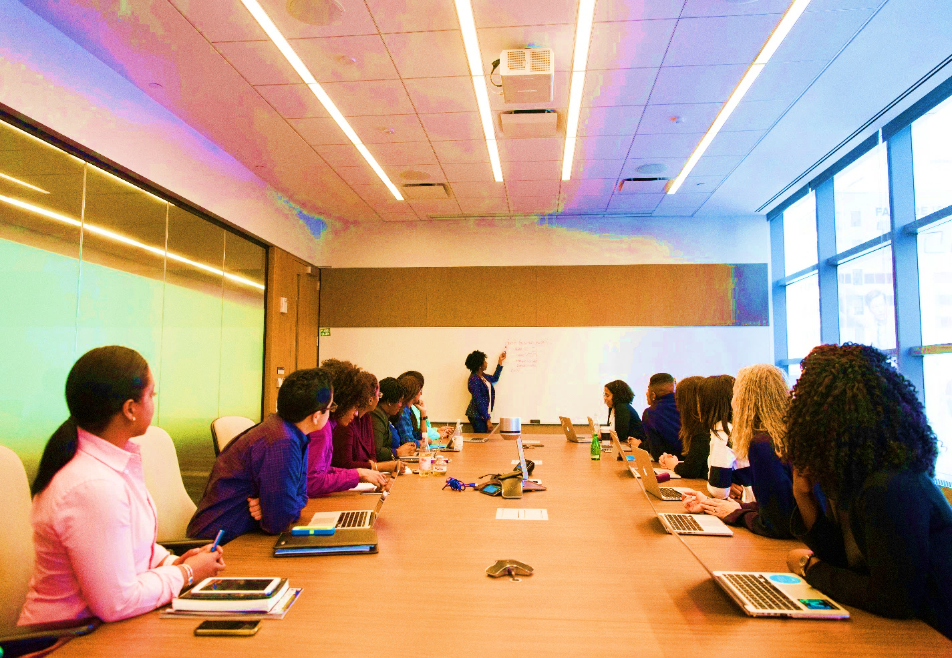
Figure 4: Emphasis on Barriers Women Face in STEM 12



Introduction
Women in Computer Science (WiCS), located at Florida International University, is a student organization in the Knight Foundation School of Computing and Information Sciences that is “for women, by women.” WiCS is dedicated to building and maintaining a productive community for technically inclined women. The club offers vital resources such as mentorship, workshops, outreach, and other events that support students pursuing computing-related degrees. In a field like computer science where men still greatly outnumber women, organizations like WiCS help young women see computing as a field where they belong and can succeed long term.
The purpose of this report is to analyze WiCS’s issues with research, recruitment, engagement, and social media presence, and to then provide feasible strategies to mend these problems. We at VAMCo aim to examine how WiCS can implement a well-structured and data driven approach to how the club is run. The goal would be for underclassmen to be exposed to the organization early, attend at least one event, and feel supported enough to remain active members throughout their time at Florida International University.
Our employees consulted directly with WiCS leadership, which led us to identify three interrelated challenges that WiCS is currently facing. Firstly, the club does not have a systematic way to gather input from underclassmen, as a result, WiCS lacks research and real data about the needs and interests of their current and potential members. This lack of data makes it difficult to tailor activities and events to what students want and need. Additionally, the club experiences inconsistent engagement with active members. While a student may attend an event once, most do not continue to engage with WiCS regularly, indicating gaps in follow-up, community building, or perceived value. This issue is made clear by the low conversion rate of first-time attendees into long-term active members. Lastly, WiCS has low social media engagement and does not seem to have a solid marketing strategy present. The club’s outreach efforts are not effectively reaching students. This leads to many underclassmen remaining unaware of WiCS or their mission. To better understand these issues, we drew information from conversations with WiCS leadership as well as extended research on STEM clubs, student engagement, marketing, and social media strategies.

To fully address these issues, this report is structured around four major tasks derived from the club’s main challenges. Task 1 focuses on finding efficient methods to gather relevant data from underclassmen interests and needs. Task 2 involves developing templates for community events and creating a recruitment strategy that prioritizes member retention. Task 3 elaborates on research into proven marketing strategies that can improve the club’s visibility and appeal to potential students. Finally, task 4 covers social media strategies from similar organizations and research that will help to enhance WiCS’s online presence. Our review suggests that consistent data collection, a clearer onboarding process, and a more involved online presence are the most effective strategies for WiCS to implement. In accordance with those challenges, this report recommends implementing an underclassmen survey, creating event and onboarding templates, and strengthening the clubs marketing and social media presence.
Key terms such as underclassmen, conversion rate, and onboarding are defined in the glossary for future WiCS leadership who may use this report. The remainder of this report is organized into Methods, Results, Conclusions, and Recommendations so that WiCS can easily see how we gathered information, what we found, and the next steps we suggest.





Methods
To investigate Women in Computer Science’s (WiCS) recruitment and engagement challenges, we used several research approaches that combined primary information from the club’s leaders, and secondary information from relevant studies. To begin with, we asked the WiCS president her thoughts on the major challenges the club was currently facing. This conversation not only led us to learn that WiCS had no formal follow-up process for interested students and did not rely on data to plan events, but also allowed us to define the scope of the problem and guide our research questions in the right direction.
Next, we performed a targeted review of recent publications that have done research on student STEM organizations, youth motivations, and social media engagement. (Blanchard et al., 2023; Davis et al., 2021; Friedmann, 2018; Hou & Macnamara, 2017; Mauk et al., 2020; Young, 2016). Key sources included a 2023 study on why students join STEM clubs (Blanchard et al., 2023), a comprehensive review of successful STEM club practices, and research on social media use in educational contexts. These scholarly sources were chosen for this report because of their direct relevance to the challenges that WiCS is currently facing.
We also explored case studies of organizations that have similar goals to WiCS. We investigated other, more successful, clubs on campus, such as Girls Who Code and campus STEM programs, to see how they stay engaged with young women while keeping their interest sustained. Most of the information we looked at from those programs were attained from external sources, however, we focused on any ideal applicable practices that aligned with our findings.
We took a data-driven approach throughout our research process. In addition to gathering qualitative ideas, we also considered quantitative approaches that WiCS could implement. We examined different methodologies for collecting student input such as traditional surveys, and more modern tools like mobile-based polling. These methods ensure that WiCS can continually learn from its target audience. One study demonstrates that message polling of college students showed high response rates when gathering feedback frequently.
Lastly, each potential solution was weighed for its evidence and practicality for a college club. By combining insights from interviews with academic research and real-world examples, we came up with a set of recommendations that are tailored to WiCS’s unique situation. The team had several meetings to compare the information we gathered with what was relevant for the club.



Results
Task 1: Understanding Underclassmen Interests and Barriers
Our analysis indicates that Women in Computer Science’s (WiCS) first priority should be to establish a basic, repeatable needs assessment process. Currently, event planning relies on intuition and informal conversations rather than solid data, which can lead to events that are well intentioned but poorly aligned with student’s interests.
The data we gathered on student organizations shows that groups are more successful when they systematically garner feedback and track participation. Needs assessments aid organizations in understanding what motivates students to join and stay, what they hope to gain, and what prevents them from attending.
During our research, we identified various factors that play into the effectiveness of a data collection method. These include sample size, budget, time, type of respondents, and depth of information needed. (Midamba et al., 2025). Based on these criteria, these two approaches are most effective:
- Semi-Structured Questionnaires
Semi-Structured Questionnaires incorporate closed questions with predetermined answers for quantitative results such as age and education level. With open questions, qualitative answers will lend more detail. They require a larger sample size to draw conclusions but are more accessible than interviews, which also require a larger budget and more time to set up.
- Small Focus Group Discussions
Focus group discussions are effective for smaller sample sizes and are useful for gathering in-depth opinions and information from a diverse group. They also serve as a great addition to survey and questionnaire data by providing more insight. Once data has been gathered from online questionnaires, WiCS can gather data from small focus group discussions for current and prospective members.

Advantage
• In-depth information
• Varied and diverse information
• Instant feedback from participants
• Flexibility and easy follow-ups
Considerations
• Select the participants with recommended sampling in mind
• Create a safe environment
• Adhere to research ethics and principles
• Engage all team members and respect opinions
• Monitor and limit time
• Make discussions interactive

Task 2: Community Events and Onboarding Strategies
This section concerns converting initial interest into sustained engagement with the club. WiCS leadership reported that many students attend one workshop but do not become regular members. Our research suggests that rather than a lack of interest, this often occurs when there is poor event design and a lack of structured onboarding.
Studies show that students stay involved when they experience enjoyable and meaningful activities, a sense of belonging and friendship, and opportunities for growth and contribution. Successful organizations typically rely on a small set of repeatable event types, each having a clear purpose. When doing research on retention for STEM clubs specifically, we identified several critical factors (Davis et al, 2021):
- Promoting sustained attendance, rather than ad hoc or sporadic attendance, makes the experience more cohesive and allows members to build knowledge over time
- STEM club activities should have socially situated, hands-on, and open-ended experiences that inspire curiosity and creative thinking. They should be informal & student driven
Onboarding strategies can naturally lead to peer mentorship and allow current members to easily transition into supportive roles where they can onboard newcomers.

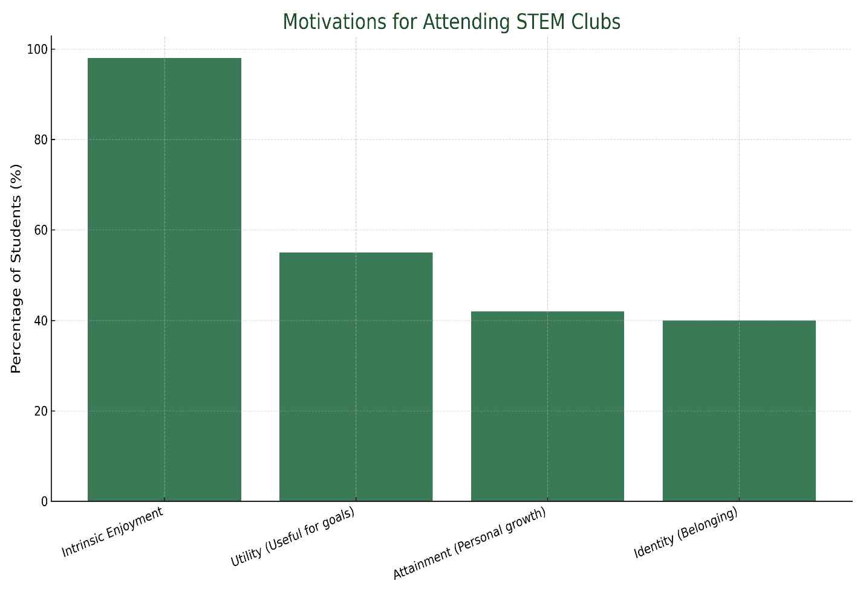
Figure 1: Graph displaying what motivates students to join STEM clubs.

Task 3: Marketing and Outreach Improvements
This task focuses on how WiCS presents itself to potential members. Our research shows that WiCS needs clearer messaging and more consistent outreach to reach their target audience. Having a clearly articulated vision plays an important role in attracting and retaining members. Therefore, effective marketing begins with a clear answer to the question, “Why WiCS?”
The club offers a supportive community of women and allies in computing, opportunities to build professional and technical skills, and mentorship and networking that can support internships and career goals. These benefits should be explicitly stated in recruitment materials rather than simply spread through word of mouth. Studies show that consistent communication about activities, outcomes, and opportunities is critical (Davis et al., 2021). Emphasizing collaboration, community, and personal development can be very persuasive.
WiCS should reach underclassmen through several points. It will be important to use multiple communication strategies. While digital communication is important, club organizations should continue to make use of traditional modes on paper (Davis et al., 2021) Opportunities to collaborate with other clubs and organizations should also be utilized to attract the attention of underclassmen. In all these tasks, the organization should have a consistent visual identity to build credibility and showcase outcomes.

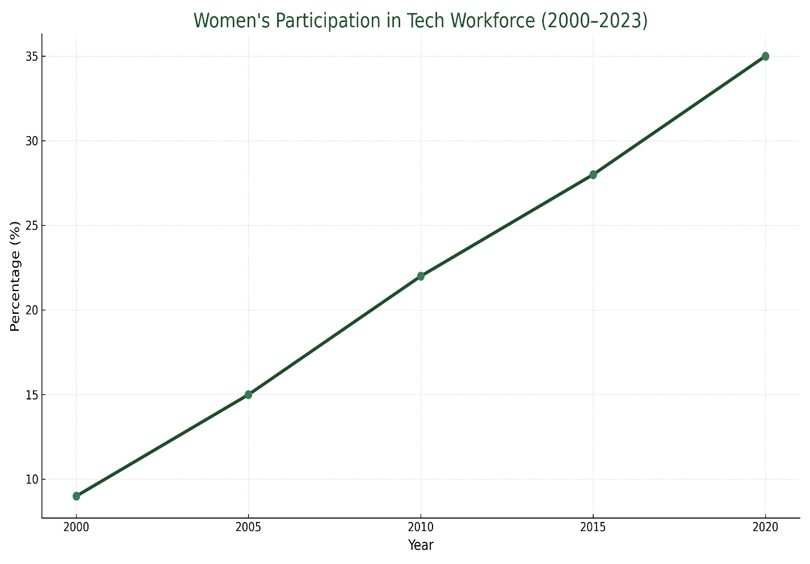
Figure 2: Graph Displaying increase in women’s participation in the tech workforce by year.

Task 4: Social Media Engagement Strategies
WiCS’s social media presence is a very important part of both recruitment and retention. However, this aspect of the club appears to be underutilized. Comparisons with other clubs suggests that WiCS can improve results by completely shifting their approach from occasional announcements to consistent community building.

University organizations tend to use social media as a one-directional bulletin board, simply posting about upcoming programming. This results in tension as students “prefer direct, peer-to-peer communication online such as posting, messaging, commenting, tags and likes,” (Hou & Macnamara et al., 2017). Macnamara’s studies identified four main characteristics of social media content that attract traffic: being original (not simply sharing or reposting), authentic (telling stories about real people, not advertising), youth-focused (incorporating popular culture) and relatable (adding value to student life). Students respond most to content that tells stories about their fellow students and role models.

Once the quality of content itself is addressed, social media optimization strategies can be further expanded upon. The underlying focus of social media optimization is again, in building community (Young, S. W. H. et al., 2016). Social media optimization implementing requires five principles: (1) Creating Shareable Content, (2) Making Sharing Easy, (3) Rewarding Engagement, (4) Proactively Sharing, and (5) Measuring Use and Encouraging Reuse. Applying these principles promote consistency while maintaining a community-focused approach.

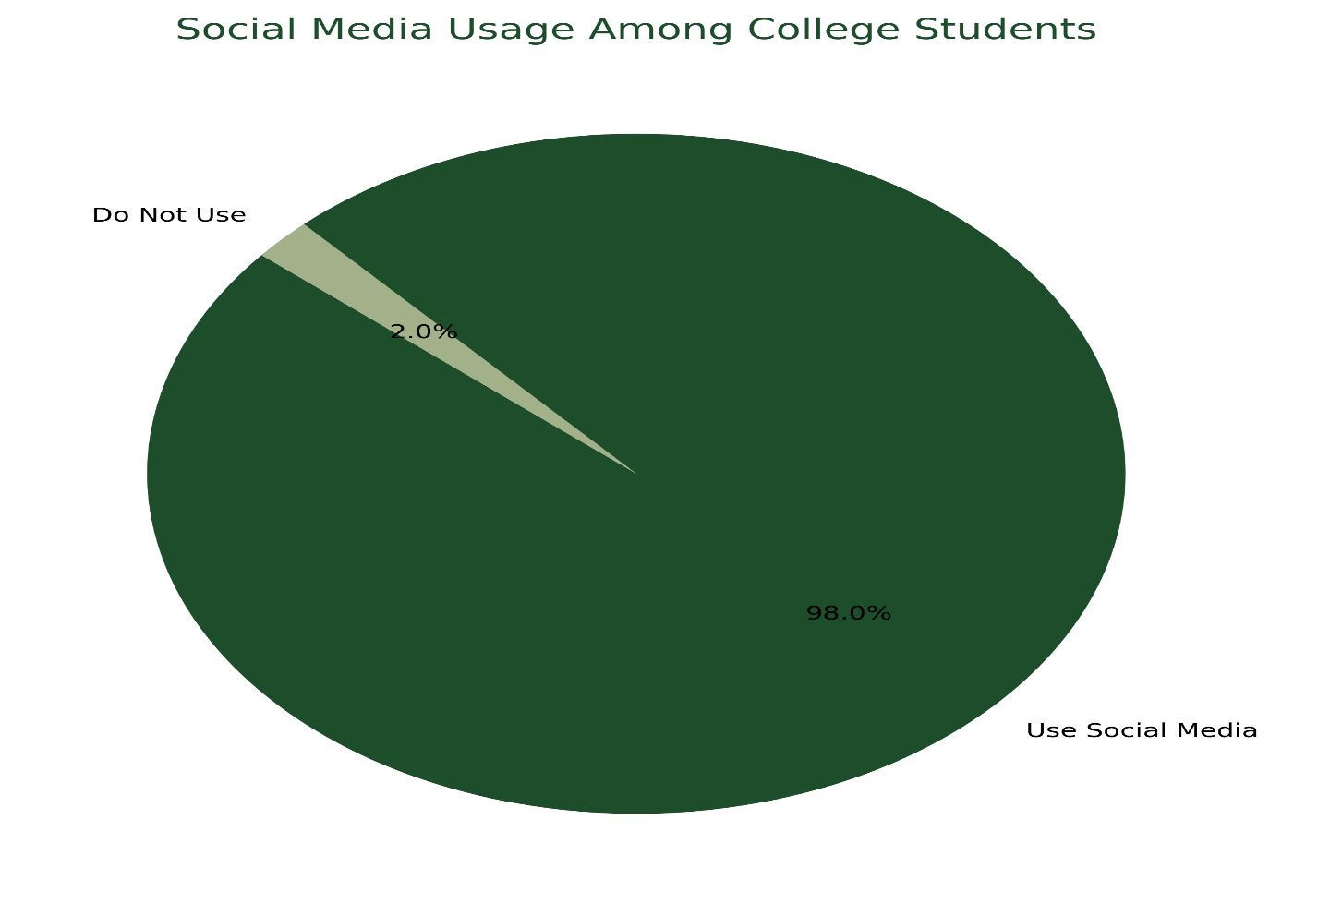
Figure 3: Graph displaying the percentage of students who use social media.
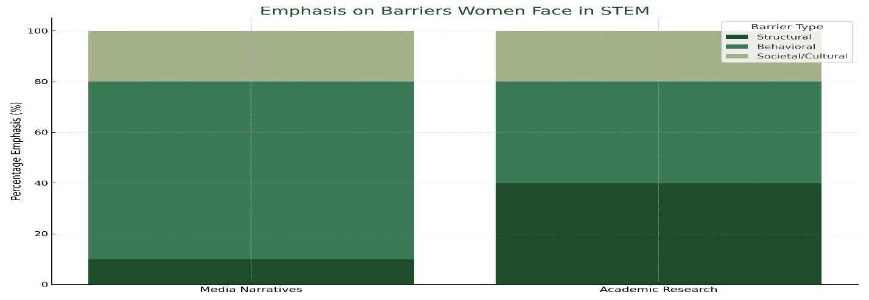
Figure 4: Graph displaying percentage of emphasis of barriers women face in STEM

Recommendations

Needs Assessment & Data Collection
Based on our research, we decided that the two best methods of data collection for Women in Computer Science (WiCS) would be (1) semi-structured questionnaires and (2) small focus group discussions.
WiCS should make use of tabling to encourage visitors to fill out online and physical survey questionnaires in exchange for a fun prize or incentive. Surveys are not only easy to distribute online with a QR code or link, but also simple to analyze. These surveys should investigate:
- Topics of interest (coding, basics, web development, interview prep)
- Desired support systems (mentorship, networking)
- Barries to participation (transportation, time, not knowing anyone)
- Personal incentives to membership (career advancement, relaxation, socializing)
- Awareness of WiCS and preferred communication channels
Once data has been gathered from the online questionnaires, WiCS can gather data from small focus group discussions for current and prospective members. Leadership from WiCS would formulate a series of guiding questions around a topic or issue and host a session with members to brainstorm and discuss. These could be done in person or virtually and would allow WiCS to gather in-depth information that could reveal nuances behind survey responses.
Implementation of these two processes are relatively simple with tools like Google Forms, Qualtrics, and Zoom paired with modest incentives and rewards. Just one round of data collection a year would give WiCS concrete evidence that can later influence their event topics, scheduling, and messaging. Over time, frequently repeating these methods would allow the club to evaluate trends and understand which changes need to be applied.

Event Templates & Onboarding
Based on our research into the elements that go into successful event programming for STEM clubs, we have decided on two important recommendations: (1) Event Templates and (2) Onboarding and Follow-Up.

Event Templates
Mentorship & Career Events
Panels or Q&A sessions with alumni, industry professionals, and senior students can provide role models and practical advice.
Hands-On Technical Workshops
Beginner-friendly coding projects, tools, and short challenges can allow underclassmen to hone their skills in a low-pressure environment.
Social & Community Events
Mixers, study jams, game nights, tournaments, movie nights, study nights, tech documentary screenings, club outings, and gatherings: all these events can contribute to a sense of belonging and help the club feel fun and safe.

Onboarding & Follow-Up
Attendance at a single event does not automatically lead to membership. Research in student organizations and STEM clubs highlights that intentional onboarding improves retention greatly. An effective onboarding process could require leadership to:

- Collect names and emails at each event (Electronic Check-In tool of choice).
- Send a short thank you message within 1-2 days: this message should briefly summarize the event, invite attendees to the next meeting, and should link WiCS’s social media or group chat.
- Host a brief orientation early in the semester specifically targeted at new members, where leadership can gather data, answer questions, and gauge interest.
- Publicize and make accessible small roles for newer members, such as contributing new ideas for a workshop, or assisting with social media.

When combined, these steps make it more likely that a first-time attendee will feel noticed, invited back, and confident enough to want to engage with the club.



Marketing & Outreach
Based on the research we found about what goes into successful marketing and outreach strategies for STEM clubs, we’ve identified the following recommendations:

Clear Messaging
WiCS currently has a strong mission statement. Their website states that their mission is …”to create a nurturing environment that provides academic, professional and emotional support to students in the field.” However, this mission statement should be prominently featured in all their recruitment materials.

WiCS can integrate this mission statement into their materials by highlighting the three tenets of their mission statement into member benefits: (1) Academic Support (2) Professional Development and (3) Emotional Support.

Diverse Marketing Strategy
Using multiple communication channels to reach diverse audience is very effective in marketing and WiCS can make use of that by improving both digital and traditional channels, as well as partnerships:

Digital Methods: Social media content, follow-up email newsletters, trending hashtags, digital events and promotions, digital bulletin boards

Traditional Methods: Flyers in strategic locations around campus, posters, tabling events, involvement and small recruitment fairs

Partnerships: Co-hosting with similar organizations, collaborating with CS department and professors


- Create Shareable Content
- Share resources that will add value (coding tutorials, guides, study tips)
- Creating original contents (infographics, curated study playlists, productivity tool recommendations, informative presentations)
- Share stories, strategies and inspiration from women in tech
- Share member stories and achievements (internships, projects)

- Make Sharing Easy
- Interactive elements (polls, questions, discussions)
- Using relevant hashtags and joining popular trends
- Clear calls to action (tagging members and partners)

- Reward Engagement
- Quickly responding to comments and messages
- Resharing member posts to display WiCS engagement
- Creating campaigns and content series

- Proactively Share
- Show behind the scenes contents of event preparation and meetings
- Share relevant news and resources (internships, scholarships, events)

- Measure Use & Encourage Reuse
- Use analytics to track follower and engagement growth
- Monitor which types of posts perform better & conduct surveys

Social Media Optimization
We recommend that WiCS shifts their approach to social media from occasional announcements to something more strategic and community focused. Before releasing content, they should ensure it’s original, authentic, youth-focused, and relatable. There should be a special focus on telling stories and spreading news about peers.
The tone of social media posts should be friendly, current and authentic rather than overly formal. Responding to comments or messages and resharing member posts can show students that WiCS is listening and values participation. This new approach can be further strengthened by implementing five principles of social media optimization. For WiCS, this would mean using various platforms to:

Conclusion
Our analysis leads to several key conclusions:

Data collection is essential. Women in Computer Science (WiCS)
needs regular input from underclassmen, and without it, planning events that align with student needs and wants is extremely challenging. Short surveys and occasional focus groups can provide a good way to gather this vital information and should become a routine part of the club’s process.

Engagement must be intentionally created. Retaining members requires more than just hosting occasional events. Onboarding, follow-up, and clear opportunities should be a routine part of the club’s work. Feelings of belonging and connection strongly influence long-term participation.

Clear messaging and visible marketing are very important to attract new members. A majority of underclassmen are unaware of WiCS or the various resources that the club offers. Without a simple consistent message, even well-planned events will struggle to draw in new students. A more focused marketing campaign can help solve this problem.

Social media is currently being underutilized by the club. WiCS currently uses social media as a one-way announcement board. Research shows that this method is simply not enough for a club to grow. Treating social media as a community space, instead, can boost both recruitment and retention.

The strategies identified in this report do not require a large budget and only need planning and consistency, meaning improvement is realistic and within reach. Over time, these practices can become part of the club’s culture, supporting a sustainable pipeline of active members and future leaders.

Glossary

- Sample size: Refers to the number of observations or data points selected from a population for a study. Selecting the right sample size is important for specific data-collection methods and to ensure accuracy and reduce bias.

- Semi-structured questionnaire: Research-backed data collection tool that incorporated both open and closed questions to capture in-depth information from respondents.

- Social media optimization: The use of various methods on social media to make a product or organization become well known and popular.

- Women in Computer Science (WiCS): An organization based at Florida International University in Miami, Florida focused on creating a nurturing environment that provides academic, professional, and emotional support to computer science students, especially women.

References

Needs Assessment & Data Collection

Midamba, D. C., Okech Francis Ndolo, Chepkoech, B., Agbolosoo, J. A., Ouya, F. O.,
Accram Jjengo. (2025). Data Collection Methods in Social Sciences: A Primer for Novice
Researchers and Students. South Asian Journal of Social Studies and Economics, 22(6),
217–229.
https://doi.org/10.9734/sajsse/2025/v22i61049

Ravert, R. D., Calix, S. I., & Sullivan, M. J. (2010). Research in brief: Using mobile phones
to collect daily experience data from college undergraduates. Journal of College Student
Development, 51(3), 343–352.
https://doi.org/10.1353/csd.0.0134
‌
Event Templates & Onboarding

Blanchard, M. R., Gutierrez, K. S., Swanson, K. J., & Collier, K. M. (2023). Why Do Students
Attend STEM Clubs, What Do They Get Out of It, and Where Are They Heading?
Education Sciences, 13(5), 480.
https://doi.org/10.3390/educsci13050480

Davis, K., Fitzgerald, A., Power, M., Leach, T., Martin, N., Piper, S., Singh, R., & Dunlop,
S.(2021). Understanding the conditions informing successful STEM clubs: What does the
evidence base tell us? Studies in Science Education, 57(2), 213–244.
https://doi.org/10.1080/03057267.2021.1969168

Social Media & Marketing:

Friedmann, E. (2018). Increasing women’s participation in the STEM industry: A first step for
developing a social marketing strategy. Journal of Social Marketing, 8(4), 442–460.
https://doi.org/10.1108/JSOCM-12-2017-0086

Hou, J., & Macnamara, J. (2017). Beyond a “spectator sport”: Social media for university
engagement and community building. Asia Pacific Public Relations Journal, 18, 102–119.
https://opus.lib.uts.edu.au/handle/10453/121586

Mauk, M., Willett, R., & Coulter, N. (2020). The can-do girl goes to coding camp: A discourse
analysis of news reports on coding initiatives designed for girls. Learning, Media and
Technology, 45(4), 395–408. https://doi.org/10.1080/17439884.2020.1781889

Young, S. W. H. (2016). Introduction to social media optimization: Setting the foundation for
building community. *Library Technology Reports, 52*(8), 5–8.
https://journals.ala.org/index.php/ltr/article/view/6093

